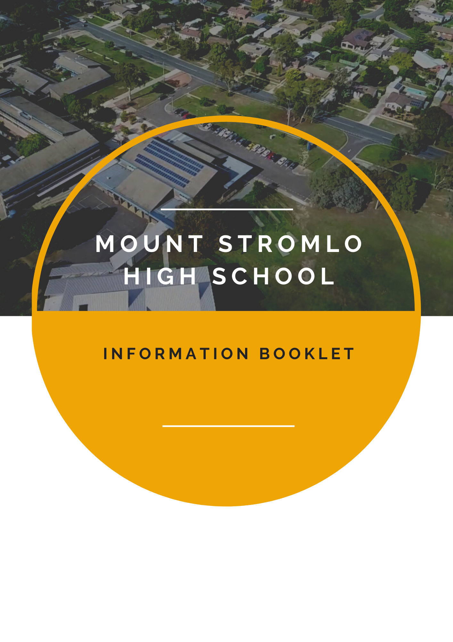





**Mount Stromlo High School**

Badimara Street

Waramanga, ACT 2611

Phone:61 2 6142 3444

Email Addresses

Student Absences: [Stromlo.Absences@ed.act.edu.au](mailto:Stromlo.Absences@ed.act.edu.au)  
Enrolment Information and Enquiries: [Stromlo.Enrolments@ed.act.edu.au](mailto:Stromlo.Enrolments@ed.act.edu.au)  
Account and Finance-related Enquiries: [Stromlo.Accounts@ed.act.edu.au](mailto:Stromlo.Accounts@ed.act.edu.au)  
Library Enquiries: [Stromlo.Library@ed.act.edu.au](mailto:Stromlo.Library@ed.act.edu.au)  
Other General Enquiries: [Stromlo.Enquiries@ed.act.edu.au](mailto:Stromlo.Enquiries@ed.act.edu.au)



Principal’s Message:

Welcome to Mount Stromlo High School.

As a Year 7 to 10 school, we cater to the individual needs of all our students by providing a nurturing, inspiring and dynamic learning community that supports students to reach their potential. High expectations are placed on students to proactively engage with their learning, attain their learning goals and achieve their best.

At Mount Stromlo High School, we are committed to continual improvement, guided by the values of **Learning**, **Respect, Endeavour** and **Pride**. Our values provide a framework to ensure students succeed academically, socially and personally through a variety of pathways, tailored to individual needs.

We are committed to developing individual talents through an engaging and individualised curriculum, with multiple extra-curricular activities available to students including school band, team sports, student leadership, performing arts productions and mentoring students at our local primary schools. In addition to the core subjects of Mathematics, Science, English, Physical Education, Humanities and Social Science, we offer programs in outdoor education, sustainability, Japanese, creative and performing arts, design and technology.

We have highly trained staff who are specialists in their area with innovative and engaging teaching practices. They are committed to building a safe and inclusive learning community for all students at Mount Stromlo High School.

A successful school has effective, positive partnerships between students, staff, parents and the wider school community. As Principal, I will maintain and continue to develop these partnerships as they enable high achievement for our students. I welcome and encourage you to become an engaged member of our school community.

If you would like to know more about our vibrant learning community, please do not hesitate to call the school to make an appointment.

Regards

Peter Radford

Contents

Principal’s Message 3

Mission and School Values 5

Mission Statement 5

School Values 5

Curriculum 7

English 7

Mathematics 8

Humanities and Social Science 8

Science 8

Languages 9

Health and Physical Education 9

The Arts 11

Technology 12

Learning Extension 12

LEX@S 12

Learning Support **Error! Bookmark not defined.**

Inclusive Philosophy 13

Inclusive Model 13

Literacy Support 13

Extra - Curricular 14

Student Support and PBL 14

Policies and Procedures 15

Timetable 17

Library 18

Getting to and from school 18

# Mission and School Values

## Mission Statement

Mount Stromlo High School strives to provide a safe and caring education environment where every student is encouraged to achieve individual excellence, self-reliance and responsibility.

## School Values

**Learning**

At Mount Stromlo, we value *Learning*. Learning provides students with a positive and productive future full of challenges and satisfaction. The quality education provided by our teachers enables our students to contribute positively and productively to our community and society.

**Respect**

*Respect* for self and for others is essential for a successful learning community.  Every member of the Mount Stromlo community respects the right of others to learn and feel safe.

**Endeavour**

We *Endeavour* to do our best in everything we do.  By participating fully in our community and seeing challenges as opportunities allows students and staff to develop a high level of self-respect and pride in their achievements. Everyone learns differently. Everyone has strengths. At Mount Stromlo students are assisted and encouraged to realise their strengths and reach their potential; and to further enhance their learning and development.

**Pride**

Personal pride and pride in the school community is an important value demonstrated at Mount Stromlo. Endeavouring to do our best; to be involved; care for others and to show initiative develops a great sense of *Pride* in personal achievements and in being a Mount Stromlo student.

|  |  |  |  |
| --- | --- | --- | --- |
|  |  |  |  |

Enrolment

Mount Stromlo High School welcomes all students from the Priority Placement Area (PPA) suburbs of Chapman, Duffy, Fisher, Holder, Rivett, Stirling, Uriarra Village, Waramanga, and Weston. Any student living in our school's PPA is entitled to a place in the relevant Year 7 – 10 cohort. Uriarra residents access schools closest to them on the transport route.  This may include Mount Stromlo High School.

Applications for enrolment for **the current year** may be lodged at any time during the year and are processed as received. Please complete an Application to Enrol/Transfer in an ACT Public School on the Education Directorate [website](https://www.education.act.gov.au/public-school-life/enrolling-in-a-public-school).  If you do not have access to the Internet please contact the school and the front office staff will assist you.

Once the online application has been received (for current year enrolments) the front office staff will contact you by phone to arrange an enrolment interview with the Deputy Principal.  Please bring:

* Proof of student's residential address (house lease, electricity account.  NB drivers’ licence and mobile phone account are not proof of address)
* Proof of student's identity and date of birth (birth certificate or passport)
* Copies of any family law or other relevant court orders relating to the student
* Emergency medical treatment plan (if required)



# Curriculum

The Mount Stromlo High School [Curriculum](http://www.mountstromlohs.act.edu.au/our_curriculum) offers a broad education within a structure that allows choice and addresses each individual's interests, needs and strengths.

The focus of the curriculum is to develop each student as a learner, a person, a member of the community and a contributor to society.  This is achieved through timetabled classroom programs and the extra-curricular opportunities available for students.

Classroom studies comprise the eight learning areas of:

* English
* Mathematics
* Science
* HaSS (Humanities and Social Sciences)
* The Arts
* Technology
* Physical Education and Health
* Languages (Japanese)

Students study eight subjects in each semester (half-year) including WHAM (Wellbeing Health Awareness and Management SEL program) for 2x 50min lessons per week.

In years 7 and 8 students are given the opportunity to study a wide range of units within the Arts and Technology area. Over the two-year period, they will complete 8 term long units of work drawn from the Arts and Technology. This experience supports a smooth transition to high school as well as encouraging wise and informed decision making in subsequent years where students choose from a range of options.

## English

***Today a reader, tomorrow a leader.*** *– Margaret Fuller*

At Mount Stromlo High School, we aim to engage students in the subject of English; challenging and deepening their understanding of literature, literacy and language through the English Textual Concepts. The study of English helps young people develop the knowledge and skills needed for education, training and the workplace. It helps them become ethical, thoughtful, informed and active members of society.

Students are given the opportunity to engage with a variety of texts including; novels, films, plays, Shakespeare, poetry, short stories, picture books, advertising materials and live performances. They listen to, read, view, interpret, evaluate and perform a range of spoken, written and multimodal texts in which the primary purpose is aesthetic, as well as texts designed to inform and persuade. Students develop their understanding of how texts, including media texts, are influenced by context, purpose and audience.

## Mathematics

Mathematics at Mount Stromlo High School is a core subject for all students in all years.  Over the four years of high school students will explore and build their skills in the numerical categories outlined in the Australian National Curriculum: *Number and Algebra, Measurement and Geometry*, *Statistics and Probability.* Numeracy is a fundamental skill that students will utilise across the curriculum and will experience in a range of subject areas.

Mount Stromlo High School students will be encouraged and invited to participate in several Mathematics events, including the Australian Mathematics Competition. Our results from previous years include several prize winners with many of the participants receiving Distinction and Credit awards. Students from Extension classes are invited to participate in the Mathematics Challenge.

At Mount Stromlo High School students in years 7 and 8 have access to the Mathletics online learning platform, while in years 9 and 10 students move to the Mathspace online platform. Additionally, all students receive an online account to access an interactive digital textbook along with a wealth of additional resources. These platforms are used to support students learning of Mathematics by digitally upskilling mathematical skill sets.

Mathematics and the ability to numerate are vital to a person's successful participation in society.  To be numerate is to use mathematics effectively to meet general demands of life at home, in paid work, and for participation in community and civic life. This is what Mount Stromlo High School strives to develop in students to help them become successful numerate adults.

## Humanities and Social Science

Humanities and Social Science is the study of History, Geography, Civics and Citizenship and Economics and Business. At Mount Stromlo High School students develop the ability and skills to become inquiring learners. This is done through developing their ability to question, think critically, solve problems and communicate. Students are encouraged to not only consider the topic at hand but also its relationship with and implications for the present and the future. In year 7 and 8, students are given the opportunity to study all four subjects.

## Science

Scientific literacy enables students to gain an understanding of the natural world, investigate and solve problems - essential skills for the 21st century learner. Students are offered a broad range of theory and practical work with an emphasis on engaging real-world activities, including laboratory-based experiments, field studies and ICT based activities. The faculty has an extensive range of scientific equipment that is used by students in practical sessions and for teacher demonstrations, including a brand-new state of the art photographic microscope, a range of optical telescopes, wireless data loggers, heart rate monitors, 3D printers and much more.

Students also have access to a range of digital resources and interactive tools delivered through our online learning platforms, Google classroom and Stile.

For many students, the Year 7 course is their first introduction to working in a science laboratory. The course develops a foundation in scientific safety, literacy and numeracy skills to ensure students can meet the expectations and demands of later years. As students progress in developing their scientific literacy, we cover a broad range of topics from the scientific disciplines of Physics, Chemistry, Earth Sciences and Biology. An emphasis is placed on developing scientific inquiry skills and making evidence-based decisions. In our Lex@s classes students take on scientific investigations as part of their extended learning.

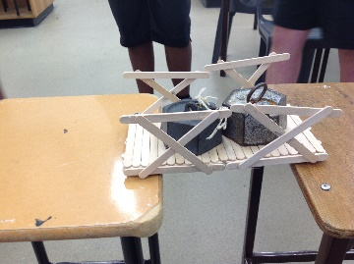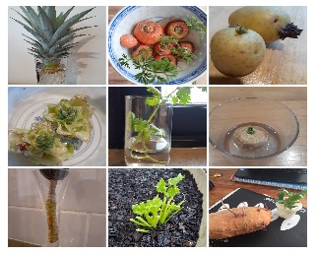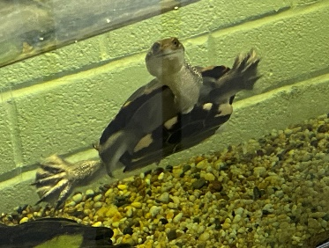

## Languages

At Mount Stromlo High School all students in year 7 and 8 are encouraged to learn a language other than their own mother tongue, as doing so enables new and different ways of seeing the world.  Students learn Japanese at Mount Stromlo High School and may continue studying Japanese as an elective choice in year 9 and 10.

***Japanese***

Students studying Japanese learn the Hiragana and Katakana scripts and begin to learn Kanji characters. Students learn the geography, history and culture of Japan, and are given many opportunities to experience Japanese culture, including Japanese art and cuisine, in classes, on-line and on excursions. A student trip to Japan is generally offered every second year dependent on departmental permission.

***External Languages Programs***

We currently have a small number of students that are studying languages other than our offered curriculum.  The list (at present) includes Indonesian, Italian and Advanced Japanese.  The programs provided are by other educational institutions. Students that are wanting to undertake learning a specific language need to discuss with the school management and we will see if we can find a workable solution.

## Physical Education

The Physical Education curriculum at Mount Stromlo High School emphasises the importance of living an active and healthy lifestyle and the need to make informed choices about lifelong activity.

Students participate in a range of fitness and skill development activities including badminton, soccer, netball, softball, hockey, AFL, dance, athletics, touch football, basketball, cricket, tennis, volleyball, sof-crosse, dance and fitness games.

Throughout the school year, students are invited to try-out for a variety of school sporting teams. These teams are coached by school staff and join school-aged competitions.

**Outdoor Education (Year 9/10 Elective):**

We offer two Outdoor Education units. Here students develop basic outdoor knowledge and skills, experiencing a range of practical learning opportunities. Activities include – rock climbing, mountain biking, caving, bushwalking, surfing activities, snow activities, environmental issues and base camping. Theoretical tasks will be paired with the practical so students can develop a holistic understanding and appreciation of the safety and environmental considerations which encompass activities in the outdoors.

**Sports Coaching (Year 9/10 Elective)**

Students develop the knowledge and skills relating to the theory and practice of coaching. They explore the theoretical components of coaching styles, the basic structure of a coaching session, coaching for individual needs (closed vs. open skills, teaching games for understanding), sports injuries and prevention and an introduction to sports psychology (communication and player motivation). Students apply the theory to practice through mini peer coaching sessions and planning, facilitating and evaluating a series of coaching sessions with primary school students.

**Sports Science (Year 9/10 Elective)**

Students investigate theoretical concepts that link to sports performance including the Muscular System, Skeletal System, and Energy Systems of the body. They use this knowledge to explore the impact of technology on sports performance and investigate their own strengths and weaknesses to develop personal training programs.

## WHAM (Wellbeing Health Awareness Management)

WHAM is a subject that incorporates wellbeing, health and SEL (Social and Emotional Learning). All students participate in WHAM for 2 lessons per week. Within WHAM students explore the Personal and Social Capabilities throughout their learning including Self-Awareness and Self-Management elements. WHAM topics include wellbeing, mental health, relationships, safe choices, risk taking, health and safety, careers, and others. These topics help students to make positive choices and connect with their personal word.

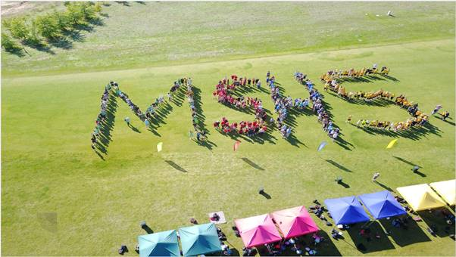

## The Arts

The Arts have the capacity to engage, inspire and enrich all students, exciting the imagination and encouraging students to reach their creative and expressive potential. The five distinct but related Arts courses — Dance, Drama, Media, Music and Visual Arts — share and communicate understanding and expressions of ourselves and others. Rich in tradition, the arts play a major role in the development and expression of contemporary cultures and communities, locally, nationally and globally.

The Arts program at Mount Stromlo High School provides students with experience and skills in all five areas of the Arts. Through the Arts, students learn to explore and express themselves as they discover and interpret the worlds around them, communicating ideas with current and emerging technologies and using arts knowledge and understanding to make sense of their worlds.

In year 7 and 8 students complete an Arts and Technology rotation which includes a selection of the following subjects; Dance, Drama, Music, Visual Art, Food Technology, Makerspace, Photography, Textiles and Woodwork. In year 9/10 students choose from a range of electives that develop technique, performance and production skills. Subjects offered may include Painting and Drawing, Printmaking, Visual Art, Digital Photography, Digital Design, Digital Art, Dance, Music Industry, Drama, Media Production and Film Making.

There are multiple performance opportunities for students throughout the school year.   Students can participate in a range of productions and events including Dance Festival, the Acting Techniques annual play, Floriade, Canberra Show, Limelight, Band Eisteddfod and various community events and fetes.  Photography and Art students regularly display their work around the school, at external exhibitions and at school events. Visual and performing arts students are invited to participate and perform in our end of year show, ‘StromFest’, which takes place over two nights at the Canberra College Theatre.

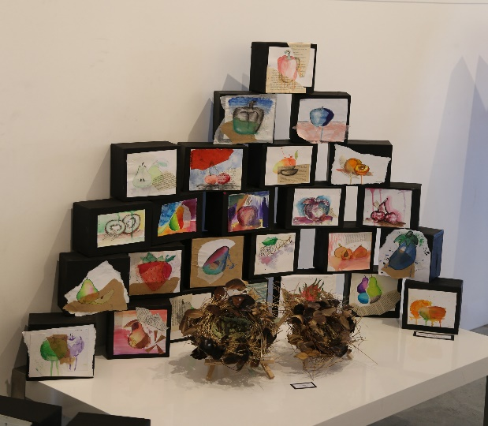 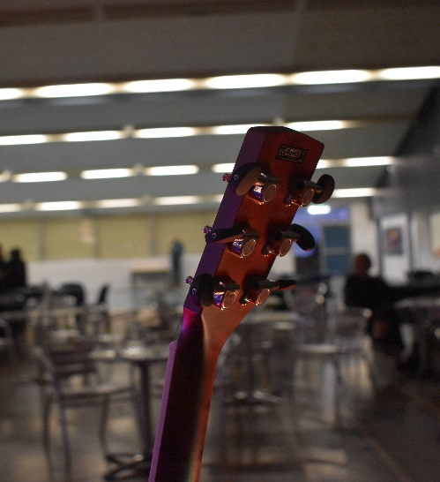

## Technology

The Technology Faculty at Mount Stromlo High School aims to provide students with engaging learning opportunities in practical environments to help students become lifelong learners. To achieve this, students are exposed to a model of learning that embraces the concepts of design, make and appraise – an approach that aims to encourage students to plan, experiment test and reflect upon the development and manufacturing processes.

In year 7 and 8 students complete an Arts and Technology rotation which includes a selection of the following subjects; Dance, Drama, Music, Visual Art, Food, Makerspace, Photography, Textiles and Woodwork. In years 9 and 10 students are able to choose from a range of electives that further develop skills and knowledge. Courses offered may include; Design and Technology, Maker-Space Projects, Robotics, Game Design, Woodwork, Metalwork, Jewellery Making, Creative Textiles, Food Technology and Hospitality.

Students are given many opportunities to showcase their work throughout the year including preparing and serving food at school functions and exhibiting work at school events.

# Learning Extension at Stromlo - LEX@S

The Learning Extension at Stromlo (LEX@S) Program is offered to suitable students from years 7-10 at Mount Stromlo High School. We recognise the need to extend students in their learning where students demonstrate an aptitude in different subjects. A range of objective and subjective measures such as CogAT, PAT, NAPLAN and performance grades along with teachers and parents' observations are used that assist in making best judgements about students' learning needs. Our program aims to appropriately challenge and extend students in one or more key learning areas; English, Maths, Science and HaSS. Students in the LEX@S Program will be offered a modified curriculum that extends learning, scope for leadership and access to extracurricular excursions among other enrichment learning opportunities.

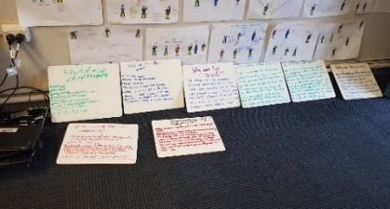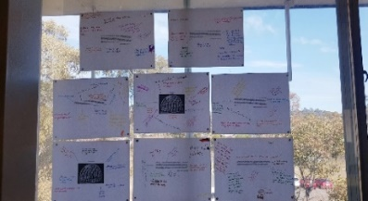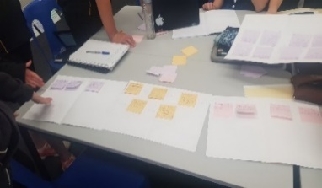

# Learning Support

## Inclusive Philosophy

Mount Stromlo High School is an inclusive school that provides a range of programs and resources to meet the individual needs of students. We adopt a flexible approach to learning and build partnerships with parents to ensure the best outcomes for students.

## Inclusive Model

At Stromlo, we operate an inclusive model of education. This means that our students with disability are supported to participate in what is primarily a mainstream education program. There is strong research evidence to show that students with additional needs benefit from an inclusive model. While there is a strong focus on supported mainstream education, our model allows for the flexibility of small group instruction when more targeted learning is necessary.

Students are supported by additional staffing which includes an Inclusion Teacher, who works with mainstream teachers in mainstream classes for HaSS, Science, Mathematics and English. Student learning programs include individualised learning plans and curriculum adjustments such as differentiated learning tasks. Learning support Assistants support our students across all classes. Additionally, each year-group cohort of students with disabilities is supported by a case-manager who is the main point of contact for the students, as well as the main contact for families and teachers of the students.

Students obtain a position in our program through the Education Directorate and in conjunction with the school psychologist.

## Literacy Support

Literacy support classes are available to Year 7 and 8 students as an alternative to learning a language. Lessons incorporate the MacqLit literacy intervention program (developed by Macquarie University) with additional small group instruction in reading and writing strategies. The aim is to further equip students with the literacy skills needed to achieve across the 7-10 curriculum.

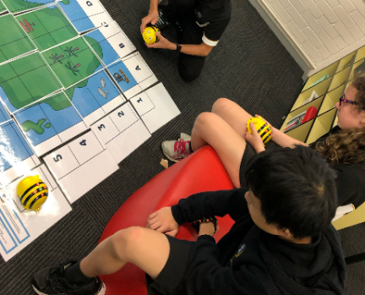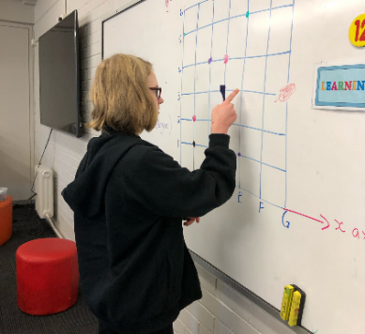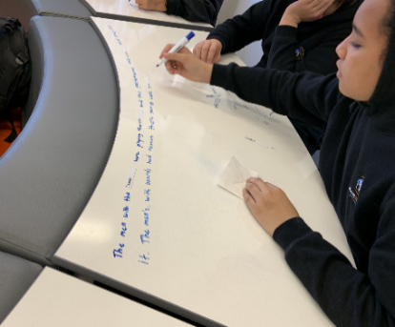

# Extra - Curricular

**Band**

Students from year 7-10 who are experienced musicians are invited to join the Concert Band. The Concert Band is an extracurricular group for woodwind, brass and percussion musicians. Repertoire comprises of music from a range of genres, including contemporary artists and soundtrack compilations. The Band performs at a range of events; these may include school assemblies, school events such as Open Night and Graduation, and external events such as the National Eisteddfod, Floriade, School Fetes and StromFest.

**Homework Club**

Mount Stromlo High School offers a homework club which runs immediately after school one day a week from 3:00pm until 4:30pm. The club is staffed by teachers from various faculties. The homework club gives students the opportunity to work on assessment items including assignments, test revision and class work, or to catch up on work missed due to absences.

**Debate Club**

Students in the Mount Stromlo Debate Club participate in the ACT Debating Union Competitions throughout the year, as well as the Interschool Parliament Debates held twice a year at the Legislative Assembly. Training is held weekly after school and provides a friendly and welcoming space for students to develop their debate skills. Students from all year groups are encouraged to participate in the Debate Club.

# Student Support

Mount Stromlo High School endeavours to provide a positive and inclusive educational environment rich in quality teaching and learning. Quality teaching is predicated on quality pedagogy, quality curriculum, and quality assessment. Student management procedures at Mount Stromlo are a partnership between students, teachers, parents and the community based on a mutual regard for our school values of **Learning, Respect, Endeavour, and Pride.**

Mount Stromlo High School’s student services processes are underpinned by a strong commitment to Restorative Practices and the belief that students need the opportunity to stop and reflect on their own behaviour and be supported to learn about appropriate behaviour for the situation.

# PBL - Positive Behaviour for Learning

Mount Stromlo High School is in its second year of Positive Behaviour for Learning. PBL is a framework schools use for everyone including students, staff, families and the school community to create a safe and supportive learning environment for all students. PBL is an international evidence-based whole school process.

At Mount Stromlo High School we are **RESPECTFUL and RESPONSIBLE LEARNERS**.

PBL underpins our positive school culture. Students who display PBL behaviours inside and outside the classroom are acknowledged by all staff in a variety of ways. Students have voice in the acknowledgements as well as the STRIPES system we are currently trialling.



# [Policies](http://www.mountstromlohs.act.edu.au/our_school/school_policies) and Procedures

**Assessment and Reporting Policy**

At Mount Stromlo the focus of assessment is to provide timely and valuable feedback to students and their parents/carers in relation to the student’s achievements towards learning goals. An essential part of our assessment is formative assessment. Formative assessment is used to monitor student learning and to provide ongoing feedback that can be used by the teacher to improve their teaching and students in turn will improve their learning outcomes. For more information please go to Assessment and Reporting section of the school website.

**Homework Policy**

The focus of homework is to consolidate learning from the classroom. Homework is intentionally designed by teachers to be relevant, challenging and meaningful. It provides the opportunity to apply what has been learnt in class, complete unfinished tasks and develop self-directed learning skills.

**Mobile Phone**

Student’s may bring a mobile phone to school. Students are to keep the phone turned off or on silent in their bag during class time. Students ae not to take photos, video or audio of anyone during the school day without the permission from a teacher and the consent of the person the recording is of.

**Uniform**

Students are encouraged to wear the school uniform with pride. Parents and students may choose from a variety of school uniform items. Some prefer the more casual option of the school polo shirt and black pants; others may choose a tailored white shirt with school logo and black pants. The variety of school uniform items ensure each person can feel comfortable in their uniform. The school uniform can be purchased from Savvy School Wear in Tuggeranong.

**Safe and Supportive School**

Everyone has the right to feel safe at school. Bullying, harassment and violence are unacceptable behaviours at Mount Stromlo High School and the community. When relationships between students become challenging and break down, we are presented with the opportunity to teach students to reflect on their behaviour, the impact it has on others and develop ways to foster appropriate relationships.

**Criteria for the Award of a Year 10 Certificate**

To be awarded a Year 10 Certificate students are required to reach a satisfactory standard for academic achievement, behaviour and attendance over the course of years 9 and 10.

# Timetable

MSHS has weekly timetable. The school day commences at 8.45am when the warning bell (song) is played and the school day ends at 3pm. There are 7 lines with 4 classes over the week and 2 lessons dedicated to WHAM (SEL program). TEAMs meet each morning for 10 minutes each morning where notices and rolls are taken.

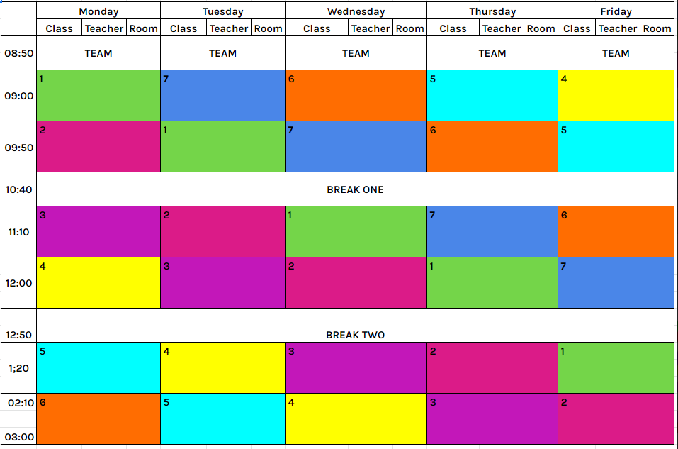

# Library

The library is a welcoming space where students can read, study and enjoy quiet social activities, such as board games. There are lots of books from every genre, and students are encouraged to provide suggestions for new books. Students can borrow books during breaks, and new books are added every month. Students can also get support accessing the Directorate’s digital collection in the library. Classroom teachers can bring students to the library to support research tasks. The library is also set up to host events, with 6 TVs, a large drop-down display screen and a library wide sound system.

# Getting to and from school

Students may walk, ride or catch a bus to school. The school has a very large bike area within which bikes, scooters and boards may be stored securely during the school day. To plan the best way to travel from home to school you may choose to use the [Transport Canberra’s Journey planner.](https://www.transport.act.gov.au/getting-around/journey-planner)

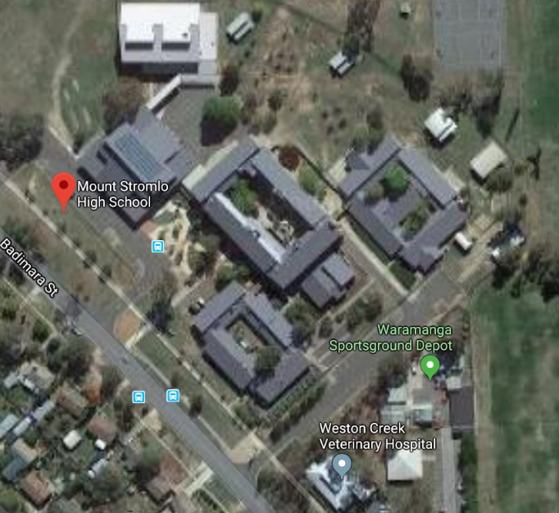

For more information about Mount Stromlo check out:

[Mount Stromlo High School website](http://www.mountstromlohs.act.edu.au/)

[Facebook](https://www.facebook.com/StromloHS/)

Or Instagram: @official_mshs

